LAB 4 – SDN

LAB 4-1

Screenshot 1 – Simple Proactive Hub Application

Screenshot 2

Screenshot 3

Screenshot 4

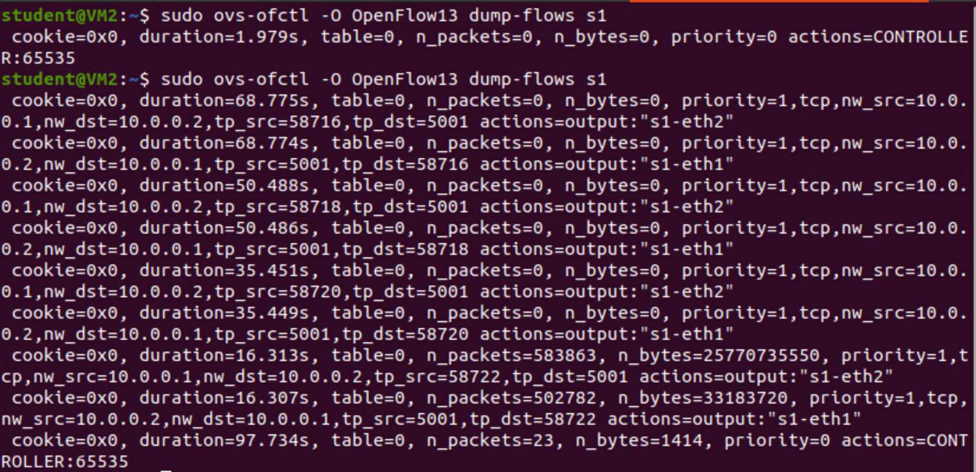

Screenshot 5

Next Page

Screenshot 6